Study Guide for EKG
MT Cardiovascular System

- What does EKG stand for and what is its purpose?

- Draw and label a normal EKG below.

- What does each part of an EKG represent?
Part on EKG | Represent
P wave
QRS complex
T wave
U wave

- Look at this EKG, focusing on the beginning half of it. Does it appear normal? Abnormal? Defend your answer.
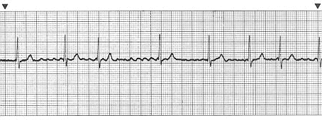

- If a person was having ventricular fibrillation, which part of an EKG would you expect to be abnormal?

