Nitrogen Cycle

- Fill in the blanks on the nitrogen cycle diagram.
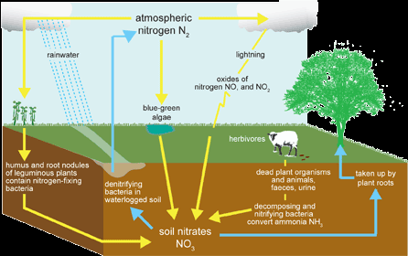

- Describe how nitrogen transfers between abiotic and biotic resources in this environment.

- Describe the role bacteria plays in this environment.

- Predict the impact of removing bacteria would have on this environment.

