Genetic Variation Examples
Population A Population B

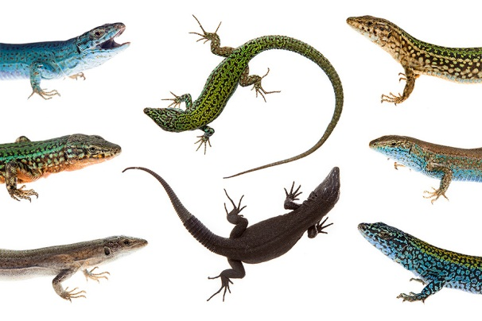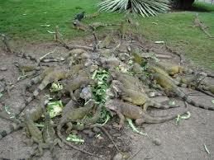

Which population of lizards will most likely survive changes in their environment?

WHY?

Population A Population B
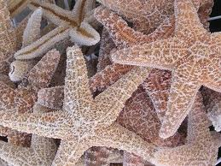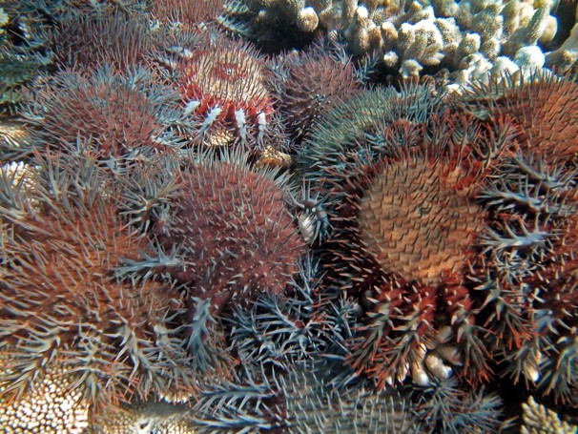
Which population of starfish will most likely survive changes in their environment?
WHY?

