Terms Study Guide
MT: Cell Processes and Chemical Reactions

 | Term | Description
1. |  | A molecule that produces energy; a chemical form of energy
2. |  | A process in which CO2, water, and sunlight create O2 and glucose
3. |  | The opposite process of photosynthesis
4. |  | The jelly-like fluid in a cell
5. |  | A type of cell that has a nucleus
6. |  | A type of cell that does not have a nucleus
7. |  | A bilayer of phospholipids that surrounds all cells and regulates what goes into and out of a cell
8. |  | A process in which glucose and O2 are used to make CO2 , water, and ATP
9. |  | In this type of cell, DNA is held in a nucleus
10. |  | This abbreviation stands for adenosine triphosphate
11. |  | An analogy to this term is a bouncer at a club that decides who to let in/out of the club

12. Label what each type of cell is and why you labeled it.
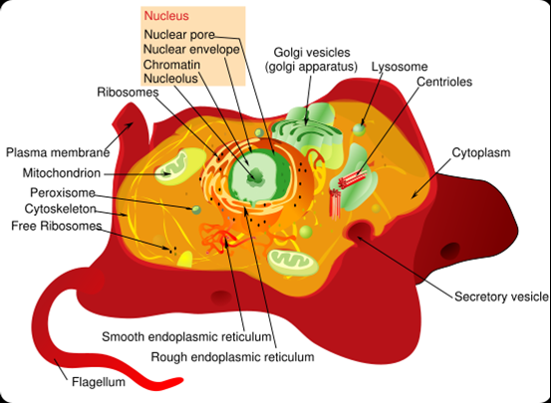
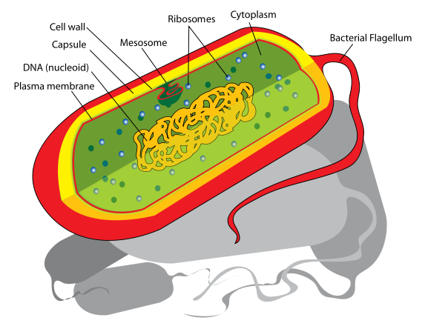

- b.

13. What process does each equation show:
a. O₂ + C₆H₁₂O₆ (glucose) = CO₂ + H₂O + ATP (energy) _______________________

b. CO₂ + H₂O + sunlight = O₂ + C₆H₁₂O₆ _______________________

