Parts of the Heart Study Guide
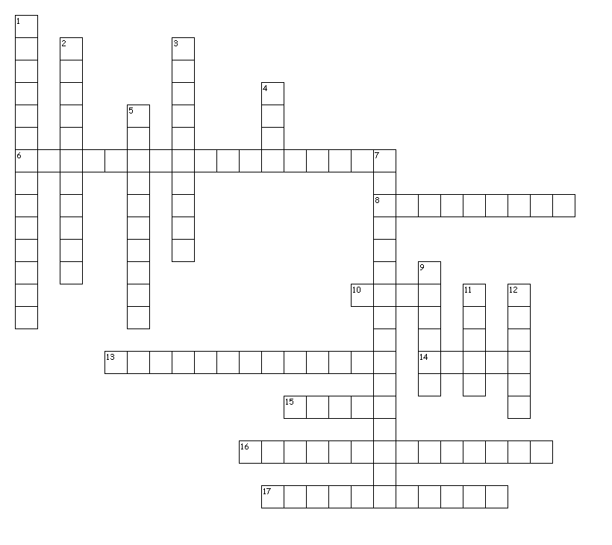
Across
13. Make a flowchart showing how blood flows through the heart starting with the right side of the heart. Include chambers and valves.
6. the only arteries that carry blood to the heart, not away from the heart
8. word that refers to lungs
10. the number of chambers the human heart has
13. the last chamber of the heart that blood flows through
14. side of the heart that deals with deoxygenated blood
15. oxygenated blood from the heart goes to the body via this major artery
16. valve that closes after blood has left the right ventricle and entered the lungs
17. the first chamber of the heart that deoxygenated blood goes into
Down
1. valve that keeps blood from flowing back into the right atrium
2. valve between the left atrium and the left ventricle
3. muscle that makes up the heart walls
4. side of the heart that deals with oxygenated blood
5. the two biggest chambers of the heart
7. deoxygenated blood from the upper body goes to the heart via this major vein
9. blood vessel that carries blood away from the heart
11. organ where blood goes to get oxygen and drop off carbon dioxide
12. part of the heart that divides the left and right sides

