Nervous and Endocrine Systems Practice Worksheet

- Draw and label the major parts of the nervous and endocrine system in the body outline below.
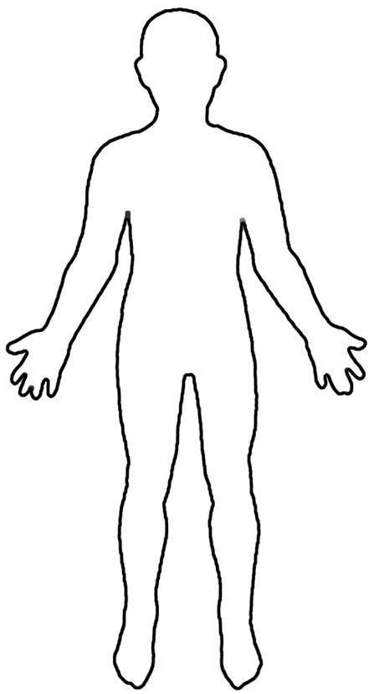
- Think of a real life situation in which a signal is sent to you brain and you respond. Describe the situation including what neurons are sending the signal and where they are sending the signal.

- Draw and label the parts of a neuron.

- Complete the following tree map.

