**Microscopic Structure of Muscle**

[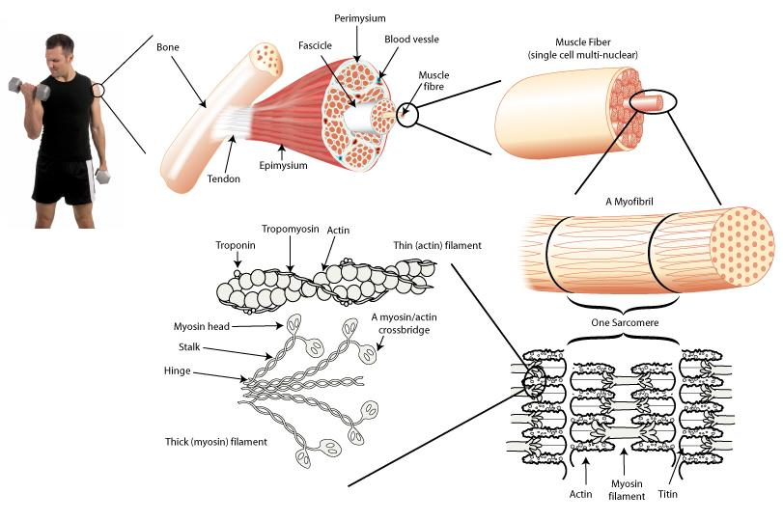](http://www.google.com/url?sa=i&rct=j&q=microscopic+structure+of+muscle&source=images&cd=&cad=rja&docid=vv4u-Elekb1J5M&tbnid=8h4erFY-X4TkCM:&ved=0CAUQjRw&url=http://www.sciencelearn.org.nz/Contexts/Sporting-Edge/Sci-Media/Images/Muscle-structure&ei=n7QbUoTAO6KoiQKgtYHwDg&bvm=bv.51156542,d.cGE&psig=AFQjCNE51biybu7x8cNc6ZcBbJabPfKolQ&ust=1377633710512379)